ASSIGNMENT : LAB-06
COLLABORATION AND AUTOMATION IN AIRTABLE

Task 1: Collaborate with Team Members in Real-Time on a Shared Base
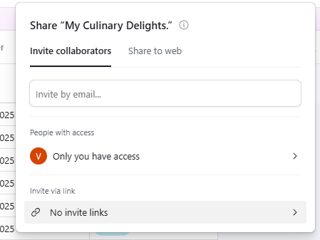
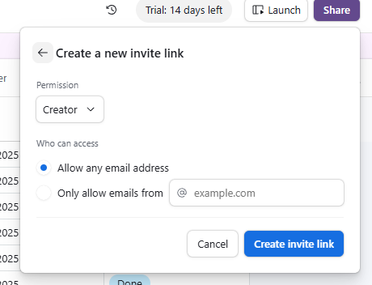
Task 2: Manage Permissions and Access Controls for Collaborators
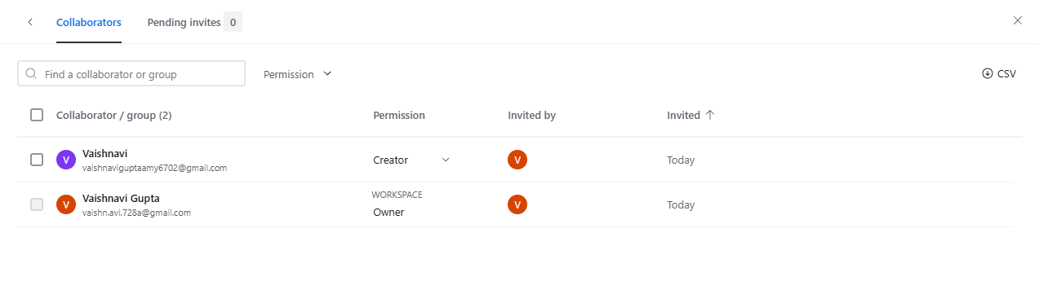

Task 3: Comment on records and mention collaborators effectively
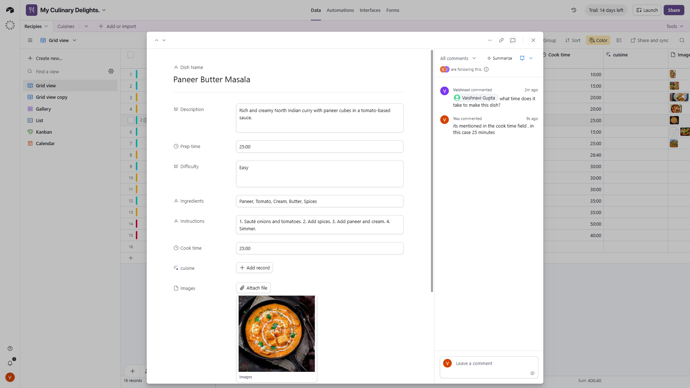

Task 4: Set up an automation that sends a notification when a specific record is updated
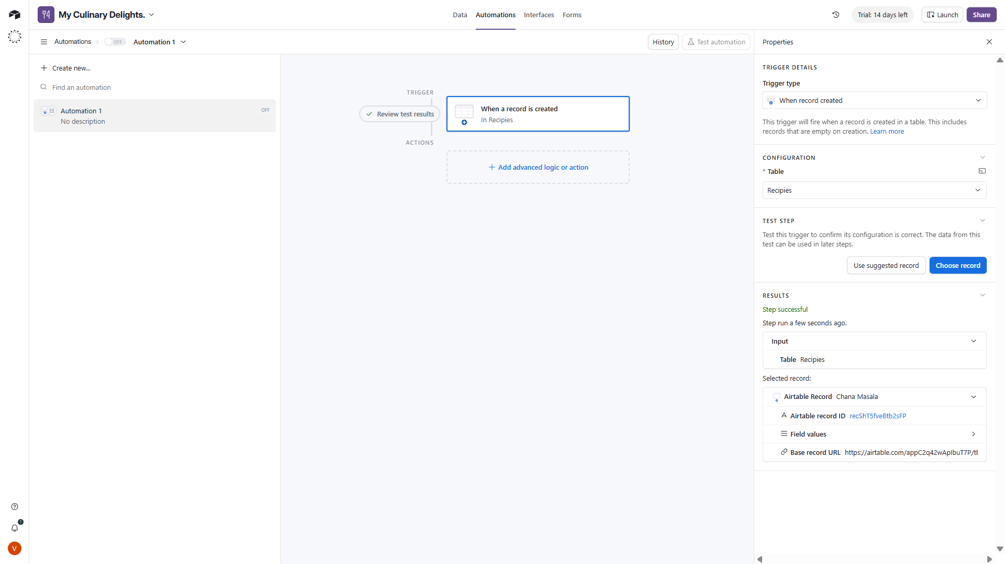

Task 5: Create and share a form with collaborators, collecting responses directly into an Airtable base.
